**Azure Setup instructions**

**Step 1: Singing into Azure**

Launch a web browser and Navigate to azure portal (<https://portal.azure.com>.). Click on sing in and Enter Azure account details and Card details. Once logged in you will be redirected to Azure dashboard.

**Step 2: Setting Up Resource Group**

In the Dashboard search for Resource group and then click on create and fill out the instruction

* **Subscription: pay-as-you-go**
* **Resource group name**: Ozmart-Aus
* **Region**: Australia Central

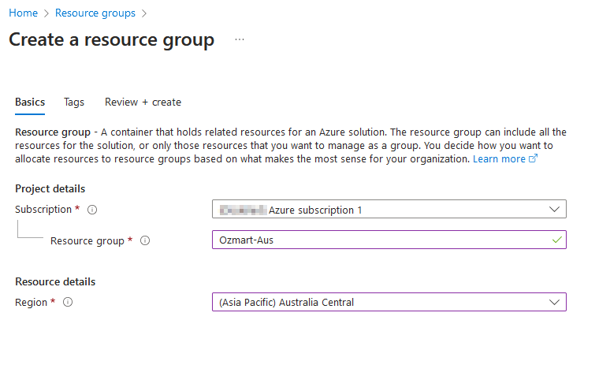

FIG: Azure Resource group creation

**STEP 3 : Create Virtual Network(Vnet)**

In the dashboard search for Virtual network and then click on create. Fill out the instruction as below

* **Subscription**: Azure Subscription
* **Resource Group**: Ozmart-Australia
* **Name**: Ozmart-MEL-Vnet
* **Region**: Australia southeast .
* **Address Space**: 10.0.0.0/16
* **Subnet**: Server(10.10.0.0/26), Laptop(10.10.0.128/26), Management(10.10.0.64/26), Firewall(10.10.0.192/26)

FIG: Azure Vnet Setup

**STEP 4 : Setting up Firewall**

Go back to the dashboard and search for the firewall and click on create. Fill out form

* **Subscription**: Azure Subscription 1.
* **Resource Group**: Ozmart-Australia
* **Name**: Ozmart-Firewall
* **Region**: Australi southeast
* **Virtual Network**: Ozmart-Mel-Vnet.

FIG: Azure Firewall setup

**STEP 5 : Create Virtual machine**

On the dashboard page search for VM and fill out the form

* **Subscription**: Azure Subscription 1.
* **Resource Group**: Ozmart-Australia
* **Virtual Machine Name**: Anupa-VM
* **Region**: Australia Southeast.
* **Image**: windows 11
* **Size**: 1gb
* **Administrator Accoun**t: amdminstrator
* **Inbound Port Rules**: allowing ports like SSH port 22 and RDP port 3389 which are necessary.

To complete, select "Review + create" and then "Create."

FIG: VM in Ozmart Environment

**STEP 6 : Vnet Peering**

Decide which of the two Vnets you wish to peer with. Scroll down to the Peering menu on the left side of the VNet menu and click on it. To start a new peering, click the Add button.

**Fill in the peering details**:

**Name:** Ozmart-Mel-to-Syd-peering

**Subscription**: Azure Subscription 1

**Virtual Network**: Ozmart-Syd-Vnet

**Virtual Network Peering Settings**:

Allow virtual network access: Set to Yes to allow resources in this VNet to communicate with the second VNet.

Allow forwarded traffic: If using a network virtual appliance to mediate traffic between VNets, this option can be set to Yes (if such an option is available).

Allow gateway transit: If the gateway is to be allowed for usage within the peering VNet, it should be set to Yes (if available).

Use remote gateways: Set to No unless you want to use a gateway from the remote VNet.

Click OK to create the peering.

STEP 7: Handling Resources on Azure

**AZURE MONITOR**

Azure monitor is used to monitor resource performance. To access Azure Monitor, put "Monitor" into the Azure portal's search box and select it. Azure Monitor is used to configure different type of alerts. We can utilise metrics section to have graphical representation of the alerts.

**Azure Subscription Management**

Bills can be paid on time and there are no backlogs by using the subscription management portal. Look over the subscriptions you currently have. To prevent unforeseen fees, set spending caps and keep an eye on consumption.

**Cost Management**

Type Cost Management + Billing in the search bar within the Azure portal and select it. Check out your spending patterns with the help of the “Cost Analysis” tool.